**Ultra-sensitive charge-sensing circuit and its post-signal processing**

Charge-sensing particle detector (CSPD) senses the current variation of an incoming ion packet and represents it as a pulse signal. It consists of two stages: a charge-voltage conversion circuit (Q-V converter) and a pulse shaper. In this work, we focus on how the Q-V converter works and introduce a post-signal processing algorithm which can recover the output signal of Q-V converter to the profile of the incoming ion packet.

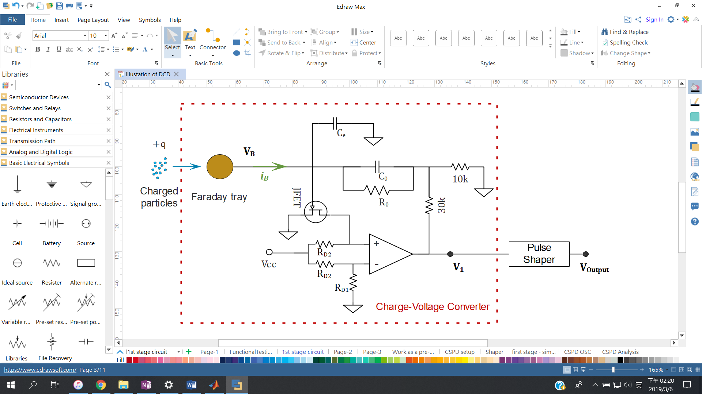

The above figure simply illustrates the CSPD and its Q-V convertor circuit, it senses the incoming charges (ions) via the Faraday tray which induces a current . That goes to three paths: a capacitor (), a resistor (), and a parasitic capacitor (); and can be written as,

|  |  |
| --- | --- |
|  | Eqn 1 |

where .

After the Laplace transform,

|  |  |
| --- | --- |
|  | Eqn 2 |

where the

And base on the golden rule of operational amplifier, we can write

|  |  |
| --- | --- |
|  | Eqn 3 |

where the denotes internal drain junction resistance and the denotes the internal transconductance of the JFET, respectively. , and , and are the dominant pole frequency and its next pole frequency, and denotes the DC open-loop gain of the op amp which is extremely large.

If we put Eqn 2 & 3 together,

|  |  |
| --- | --- |
|  | Eqn 4 |

After a bit re-arrangement,

|  |  |
| --- | --- |
|  | Eqn 5 |

The equation shows that is nearly a constant, so . It says that Eqn 1 can be simply represented as

|  |  |
| --- | --- |
|  | Eqn 6 |

That says we can estimate the current which induced by approaching charges.

(Math) From Taylor expansion to Richardson extrapolation

|  |  |
| --- | --- |
|  | Eqn 8 |

|  |  |
| --- | --- |
|  | Eqn 9.1 |
|  | Eqn 9.2 |

|  |  |
| --- | --- |
|  | Eqn 10 |

|  |  |
| --- | --- |
|  | Eqn 11 |

|  |  |
| --- | --- |
|  | Eqn 12 |

|  |  |
| --- | --- |
|  | Eqn 13 |

(Discrete signal processing)

Continued and discrete signal

|  |  |
| --- | --- |
|  | Eqn 14 |

Where denotes time interval of sampling and denotes the sample

That said, the first-order deviation of at timing the sample point () can be estimated via

|  |  |
| --- | --- |
|  | Eqn 15 |

Here we can represent the eqn 6 as the below

|  |  |
| --- | --- |
|  | Eqn 16 |

Or

|  |  |
| --- | --- |
|  | Eqn 17 |

[**Error estimation**]

The RC discharge term makes that the first stage outputs has a falling signal along a function as below,

|  |  |
| --- | --- |
| In discrete form, the above equation can be shown as,  or | Eqn 18 |

Where the q denotes approached charge. And, the eqn 17 is used to eliminate this discharging term shown in eqn 18, so we can estimate its residue error if we put the eqn 18 into the eqn 17.

|  |  |  |
| --- | --- | --- |
| |  | | --- | |  | | Eqn 19 |

[**Digital Filter**]

|  |  |
| --- | --- |
|  | Eqn 20 |

## Reference Python codes

Here we provide reference codes for post processing of CSPD 1st stage signal.

|  |
| --- |
| Code 1. Function of Signal Reconstruction |
|  |

` `

|  |
| --- |
| Code 2. Function of Signal Filtering |
|  |

|  |
| --- |
| Code 3. Load Files & Signal Processing |
|  |

Raw V1 signal, acquired with 5µs sampling interval and 540kHz bandwidth

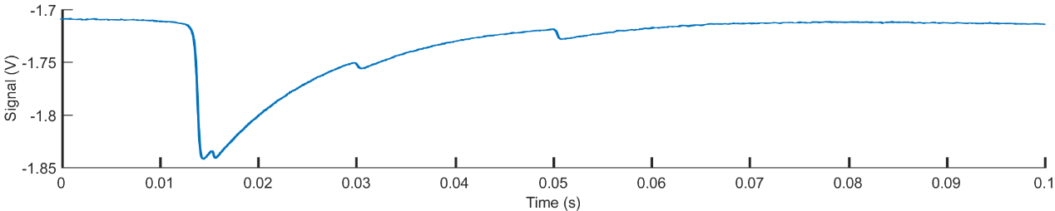

Reconstructed V1 signal

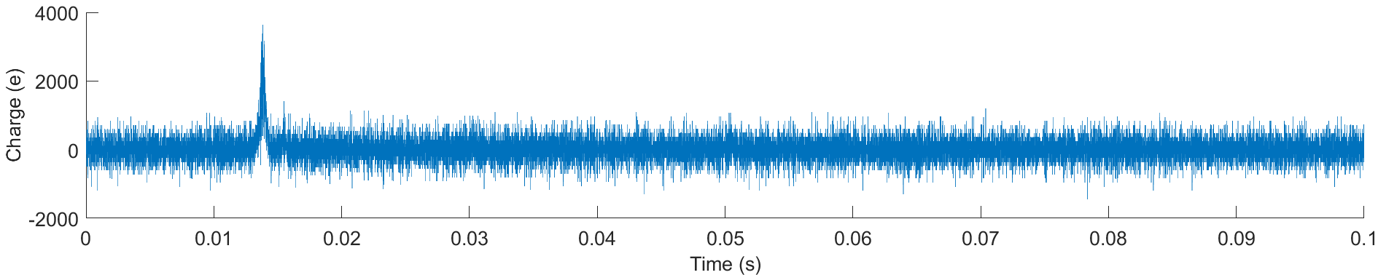

Reconstructed V1 signal filterred by a kernel of Gaussian function (WinType = Norm) of 0.3ms width

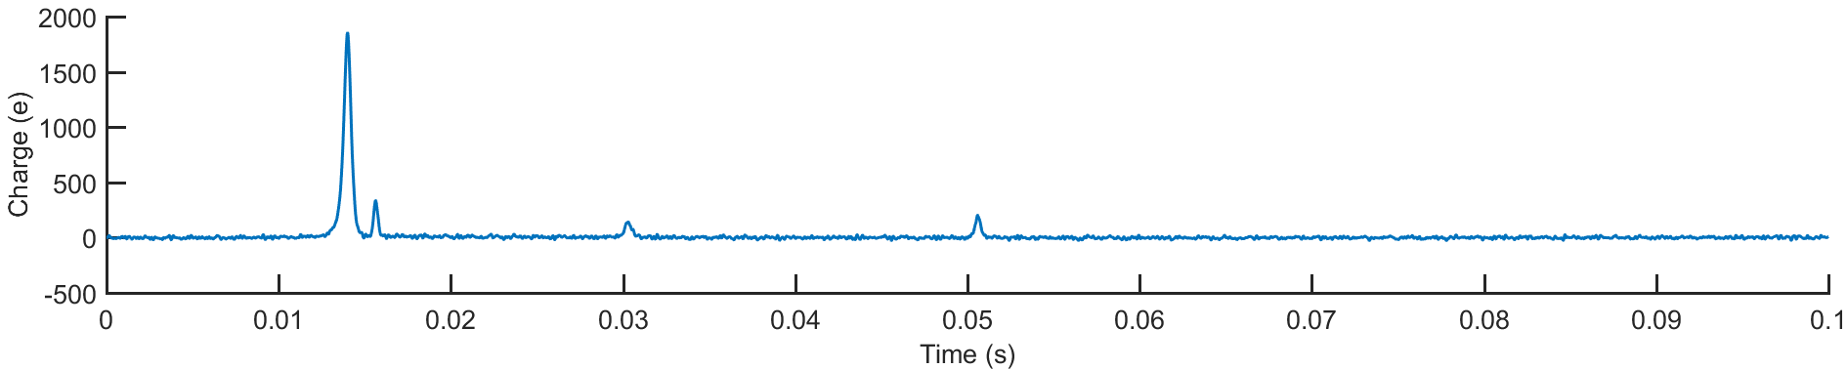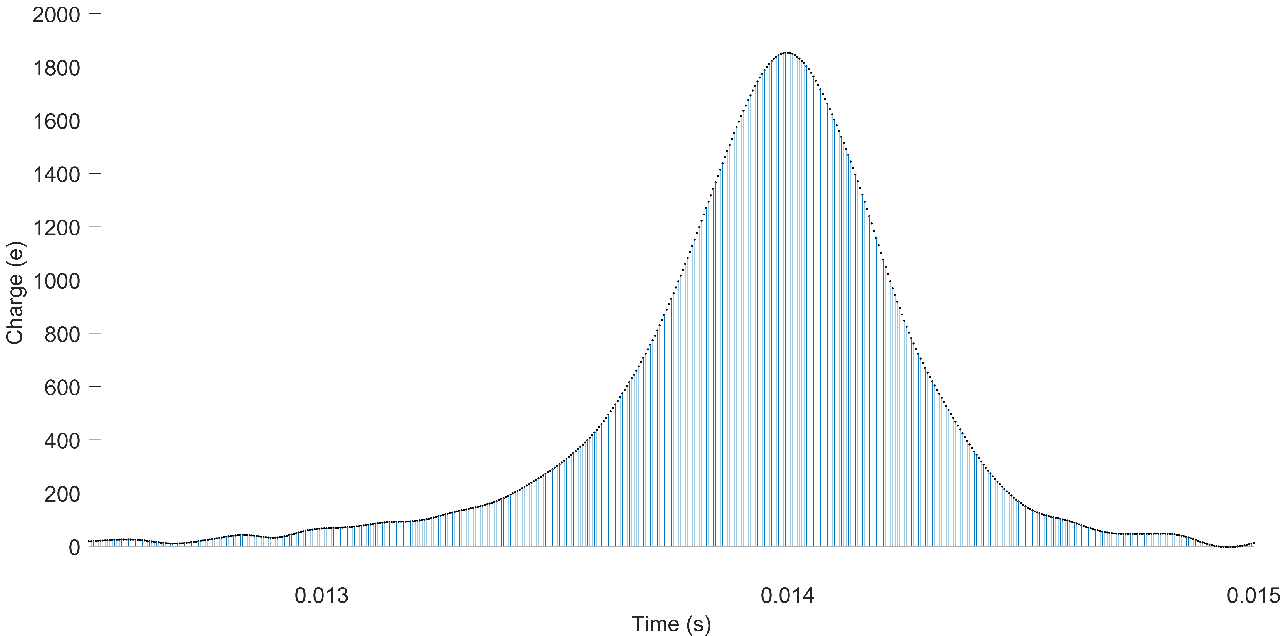

(sum of every points of a peak)